**Table of Contents**

**1. Introduction 5**

1.1 Document Purpose **5**

1.2 Project Background **5**

1.3 Aim & Objectives **5**

**2. Business Requirements Overview**…………………………………………………………**6**

**3.Functional Requirements** **6**

3.1 Tenant Module **6**

3.2 Owner Module **6**

3.3 Admin Module **6**

**4.** **Non-Functional Requirement………………………………………………………………7**

**5. Use Case Diagram 8**

5.1 Admin **8**

5.2 Owner **9**

5.3 Tenant **10**

**6. Database Design 11**

1 Login **11**

2 Tenant **11**

3 City **12**

4 Owner **12**

5 Area **12**

6 Role **12**

7 Payment **13**

8 Subscription **13**

9 Property **13**

10 Property Type **14**

11 Facility **14**

12 Facility Property…………………………………………………………………………………**14**

**7. E-R Diagram………………………………………………………………………………………15**

**8. Snapshots 16**

**9. Conclusion 31**

**List of Figures**

**Use Case Diagrams 8**

Fig 1 Admin 8

Fig 2 Owner 9

Fig 3 Tenant 10

Fig 4 ER Diagram 15

1. **Introduction:**
   1. **Document Purpose:**

This document communicates the business requirements and scope for developing Home Rental. The scope of this document is to define the functional and non-functional requirements, business rules and other constraint requirements.

## Project Background:

When someone is relocating to a new location he/she faces issues for accommodation & living. As well as Property owners don’t have any specific platform to advertise their properties. There is no transparency between tenants & property owner. No facility is present for the tenants and buyers to know the property rates at different locations. Property owners also finds difficulty to target right customers where they can rent their properties for achieving high profits.

## Aim & Objectives:

The project’s goal is to create a user-friendly and efficient online platform for everyone to rent different properties on a single place. Tenants can access detailed information about the property and can compare different properties to find suitable one. Once selection of property is done, property owners & customers can directly communicate and can make a deal without any involvement of broker.

1. **Business Requirements Overview:**

* Home Rental is the online web platform.
* There are mainly two types of users. Two types of users- owner who want to rent property & tenant who are looking for property to live.
* Property owners can list down their properties on website and can find expected tenant.
* Tenants can search for properties available on the website and even the details about the property owners.
* Home Rental provides the transparency which makes business between tenant and the property owner more easy.
* Administrators have access to manage the application.
* Home Rental will be opened to the global, but in the phase 1, the main target is in the India.

# Functional Requirements Overview:

The Home Rental consists of three modules described below.

1. Administrator Module
2. Tenant Module
3. Home Owner Module

# **3.1 Administrator Module**

* Validate properties & accounts.
* Admin can remove invalid properties & accounts.

# **3.2 Tenant Module**

* Tenant can register and create his own account.
* Tenant can compare multiple properties & will be able to choose property according to his requirement.
* Tenant can rent a property by contacting property owner.
* Tenant can request for owner information as well as property information.

# **3.3 Home Owner Module**

* Property owner can register and create his own account.
* Home Rental provides the function which allows property owners to publish his property for renting.
* Owner can remove his property from listing .
* Owner can see and manage customer requests who are interested in respective property.
* Owner can confirm deal with customer privately.
* Owner can see and manage his properties.
* He /She is able to browse existing Market price.

1. **Non-Functional Requirement:**

* The website should use a decent look, feel, and color.
* Users will not have limitations for accessing the application through the Internet. The portal being an internet application, customer will get support anytime on the website.
* Being a public website, the site must follow general usability guidelines for menus, navigation, colors, links and other actions provided on the screens.
* The system should be designed in such a manner that customer can find home easily with our home rental web support.
* Website will suggest to customers about the homes through the images.

## 5. Use-Case Diagram

**5.1 Admin:**

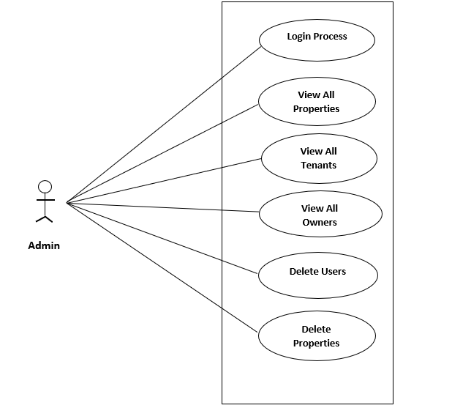

Fig. Use-Case Diagram for Admin

## 5.2 Owner:

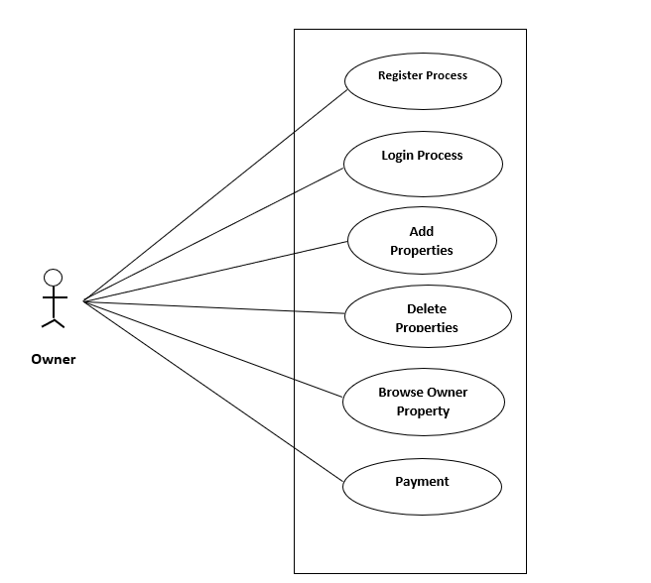

Fig. Use-Case Diagram for Owner

**5.3 Tenant:**  
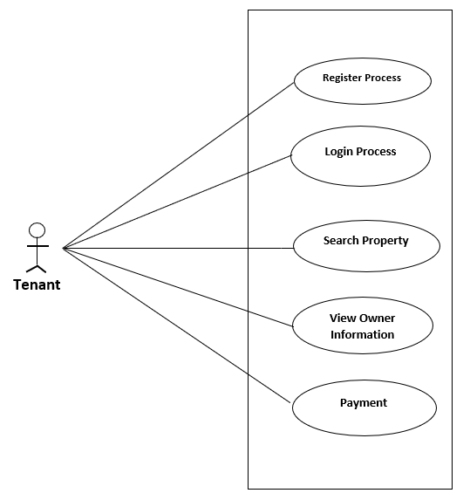

Fig. Use-Case Diagram for Tenant

**6. Database Design:**

**1] Login table:-**

|  |  |  |  |  |  |
| --- | --- | --- | --- | --- | --- |
| **Field** | **Type** | **Null** | **Key** | **Default** | **Extra** |
|
| id | int | NO | PRI | NULL | auto_increment |
| email | varchar(255) | NO | UNI | NULL |  |
| password | varchar(255) | NO |  | NULL |  |
| role_id | int | YES | FK | NULL | Role(id) |
| Status | tinyint | NO |  | NULL |  |

**2] Tenants:-**

|  |  |  |  |  |  |
| --- | --- | --- | --- | --- | --- |
| **Field** | **Type** | **Null** | **Key** | **Default** | **Extra** |
| id | int | NO | PRI | NULL | auto_increment |
| fname | varchar(255) | NO |  | NULL |  |
| lname | varchar(255) | NO |  | NULL |  |
| area_id | int | YES | FK | NULL | Area(id) |
| no_of_req_rem | int | YES |  | NULL |  |
| login_id | int | YES | FK | NULL | Login(id) |
| payment_id | int | YES | FK | NULL | Payment(id) |
| address | varchar(255) | NO |  | NULL |  |
| contact_no | varchar(20) | NO |  | NULL |  |

**3] City:-**

|  |  |  |  |  |  |
| --- | --- | --- | --- | --- | --- |
| **Field** | **Type** | **Null** | **Key** | **Default** | **Extra** |
| id | int | NO | PRI | NULL | auto_increment |
| name | varchar(255) | NO |  | NULL |  |

**4] Owners:-**

|  |  |  |  |  |  |
| --- | --- | --- | --- | --- | --- |
| **Field** | **Type** | **Null** | **Key** | **Default** | **Extra** |
| id | int | NO | PRI | NULL | auto_increment |
| fname | varchar(255) | NO |  | NULL |  |
| lname | varchar(255) | NO |  | NULL |  |
| area_id | int | YES | FK | NULL | Area(id) |
| add_property_request_rem | int | YES |  | NULL |  |
| login_id | int | YES | FK | NULL | Login(id) |
| payment_id | int | YES | FK | NULL | Payment(id) |
| address | varchar(255) | NO |  | NULL |  |
| contact_no | varchar(20) | YES |  | NULL |  |

**5] Area:-**

|  |  |  |  |  |  |
| --- | --- | --- | --- | --- | --- |
| **Field** | **Type** | **Null** | **Key** | **Default** | **Extra** |
|
| id | int | NO | PRI | NULL | auto_increment |
| name | varchar(255) | NO |  | NULL |  |
| pincode | varchar(255) | NO |  | NULL |  |
| city_id | int | YES | FK | NULL | City(id) |

**6] Role:-**

|  |  |  |  |  |  |
| --- | --- | --- | --- | --- | --- |
| **Field** | **Type** | **Null** | **Key** | **Default** | **Extra** |
| id | int | NO | PRI | NULL | auto_increment |
| name | varchar(255) | NO |  | NULL |  |

**7] Payment:-**

|  |  |  |  |  |  |
| --- | --- | --- | --- | --- | --- |
| **Field** | **Type** | **Null** | **Key** | **Default** | **Extra** |
| id | int | NO | PRI | NULL | auto_increment |
| login_id | int | yes | FK | NULL | Login(id) |
| subscription_id | int | yes | FK | NULL | Subscription(id) |
| date | date | YES |  | NULL |  |
| amount | decimal(10,2) | YES |  | NULL |  |
| transaction | varchar(255) | YES |  | NULL |  |

**8] Subscription:-**

|  |  |  |  |  |  |
| --- | --- | --- | --- | --- | --- |
| **Field** | **Type** | **Null** | **Key** | **Default** | **Extra** |
|
| id | int | NO | PRI | NULL | auto_increment |
| no_of_requests | int | NO |  | NULL |  |
| amount | decimal(10,2) | NO |  | NULL |  |
| no_of_properties | int | NO |  | NULL |  |

**9] Property:-**

|  |  |  |  |  |  |
| --- | --- | --- | --- | --- | --- |
| **Field** | **Type** | **Null** | **Key** | **Default** | **Extra** |
| id | Int | NO | PRI | NULL | auto_increment |
| owner_id | int | YES | FK | NULL | Owners(id) |
| area_id | int | YES | FK | NULL | Area(id) |
| property_type_id | int | YES | FK | NULL | Property_Type(id) |
| property_name | varchar(255) | YES |  | NULL |  |
| pdesc | text | YES |  | NULL |  |
| price | decimal(10,2) | YES |  | NULL |  |
| Deposit | decimal(10,2) | YES |  | NULL |  |

**10] Property_Type Table :-**

|  |  |  |  |  |  |
| --- | --- | --- | --- | --- | --- |
| **Field** | **Type** | **Null** | **Key** | **Default** | **Extra** |
|
| id | int | NO | PRI | NULL | auto_increment |
| name | varchar(255) | NO |  | NULL |  |

**11] Facility:-**

|  |  |  |  |  |  |
| --- | --- | --- | --- | --- | --- |
| **Field** | **Type** | **Null** | **Key** | **Default** | **Extra** |
|
| id | int | NO | PRI | NULL | auto_increment |
| name | varchar(255) | NO |  | NULL |  |

**12]Facility Property:-**

|  |  |  |  |  |  |
| --- | --- | --- | --- | --- | --- |
| **Field** | **Type** | **Null** | **Key** | **Default** | **Extra** |
| id | int | NO | PRI | NULL | auto_increment |
| property_id | int | YES | FK | NULL | Property(id) |
| facility_id | int | YES | FK | NULL | Facility(id) |
| mdesc | varchar(255) | YES |  | NULL |  |

## ER-Diagram:

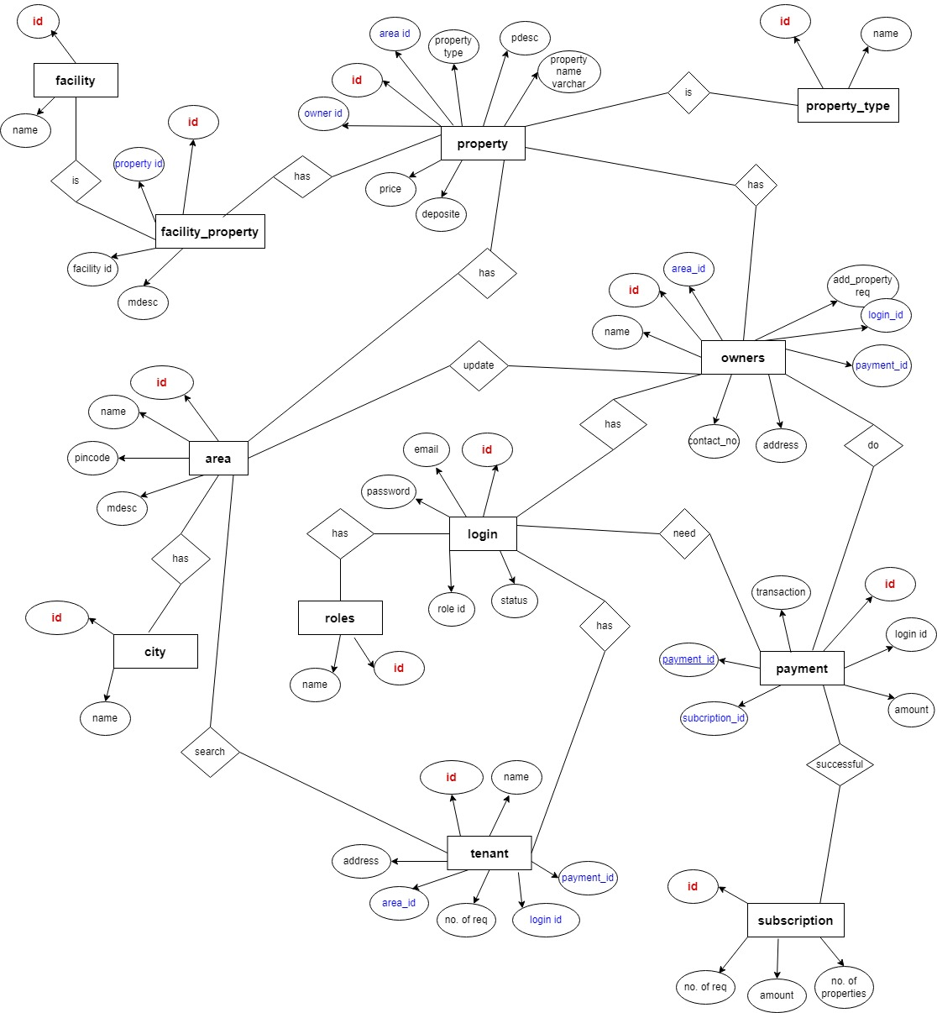

**E-R diagram shows database of Home Rental System**

**8. Snapshots:**

**8.1 Home Page:**

Following snapshot shows the Home page for Home Rental System before Login.

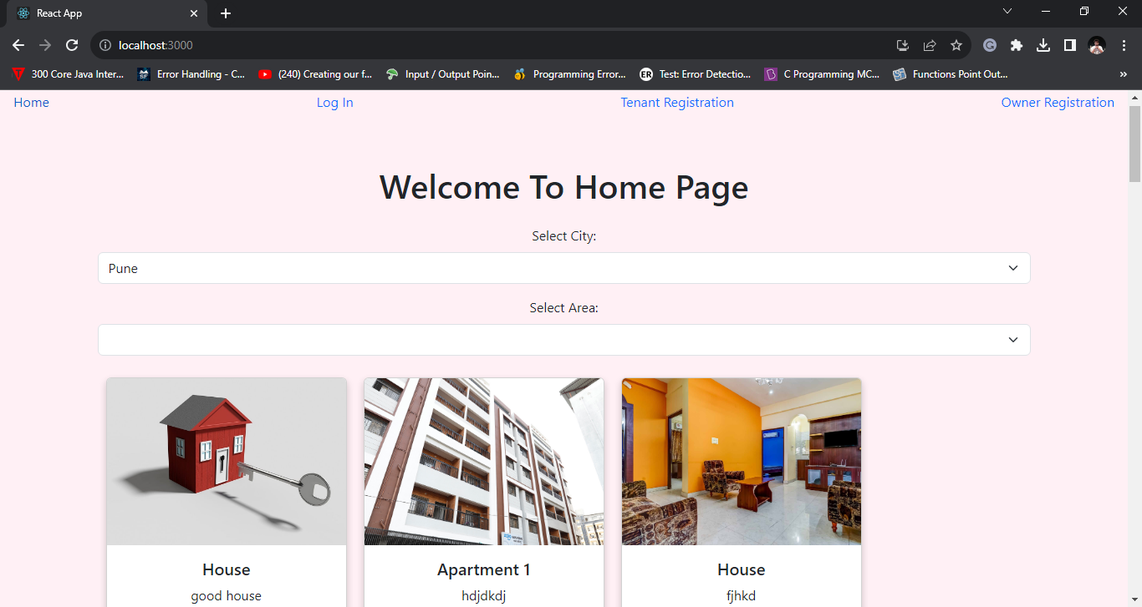

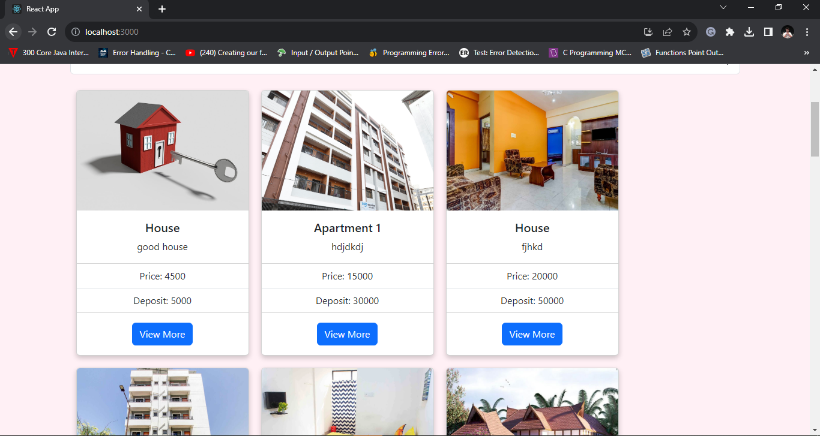

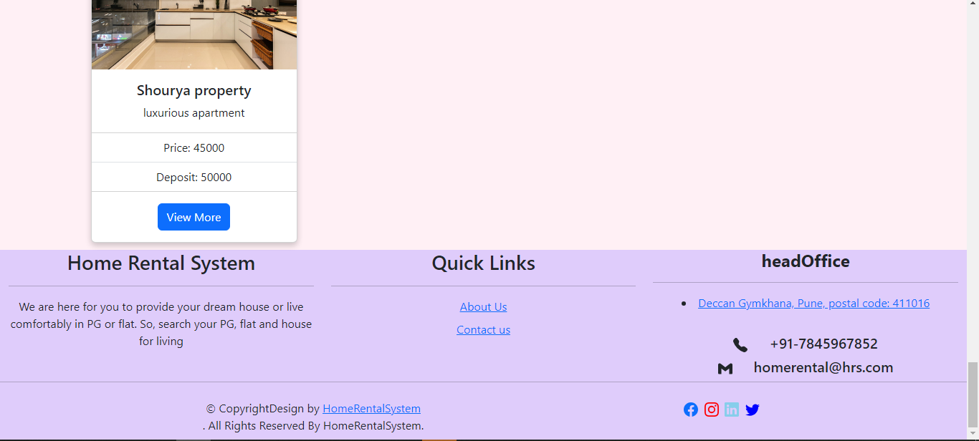

This page contains following controls

* Home
* Log In
* Tenant Registration
* Owner Registration

This page also contains footer consisting information about the website and contact us details.

**8.2 Login Page**

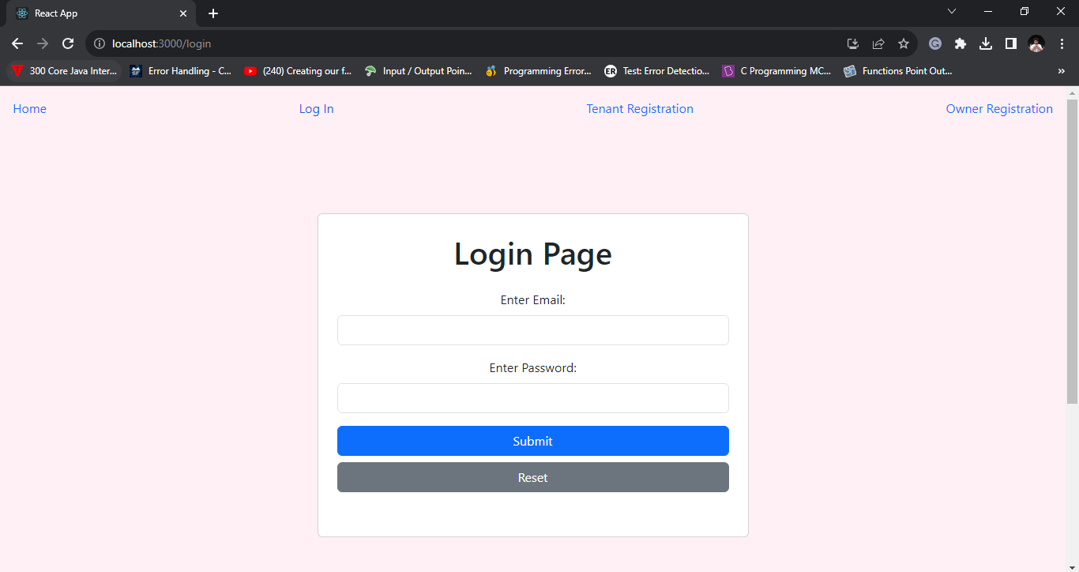

**8.3 Admin**

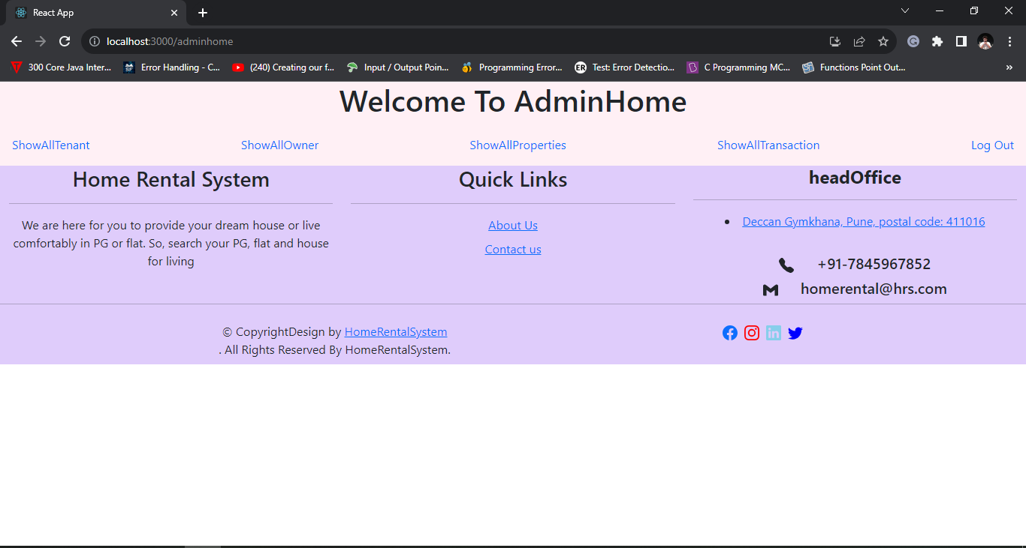

**8.3.1 Admin Home Page**

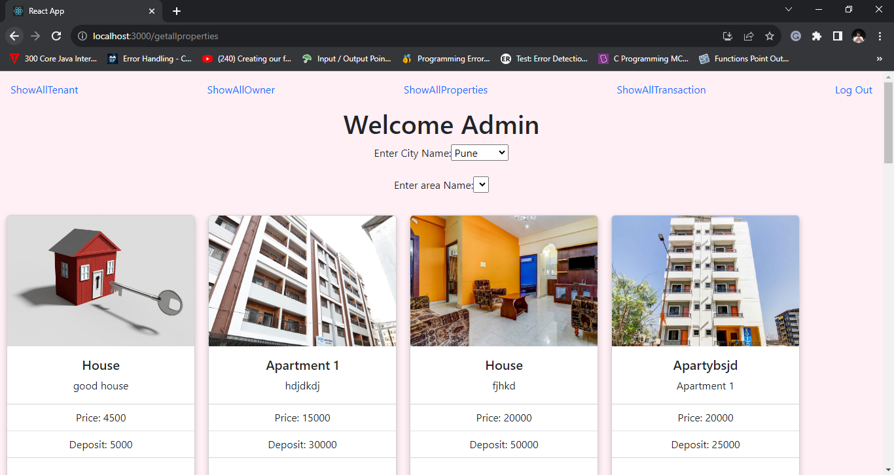



**8.3.2 Admin - Show All Tenant Detail**

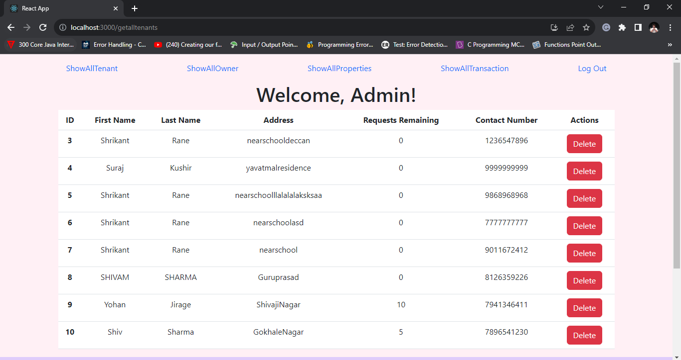

**8.3.3 Admin - Show All Owner Details**

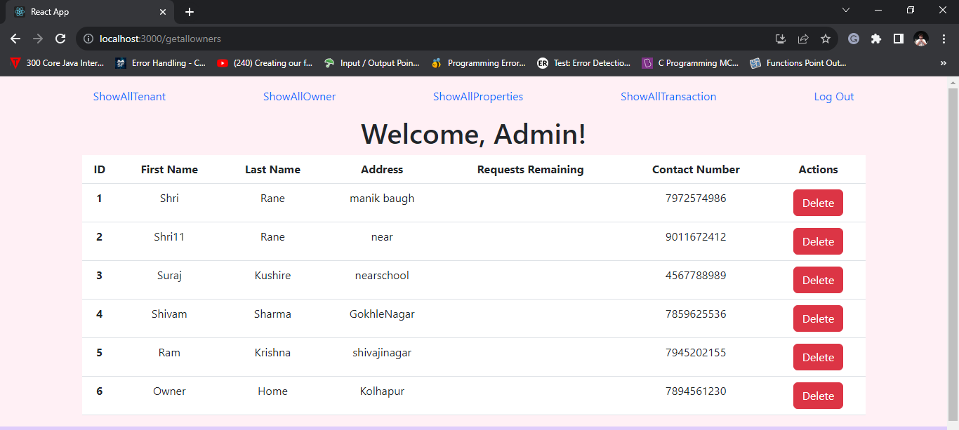

**8.3.4 Transaction Details**

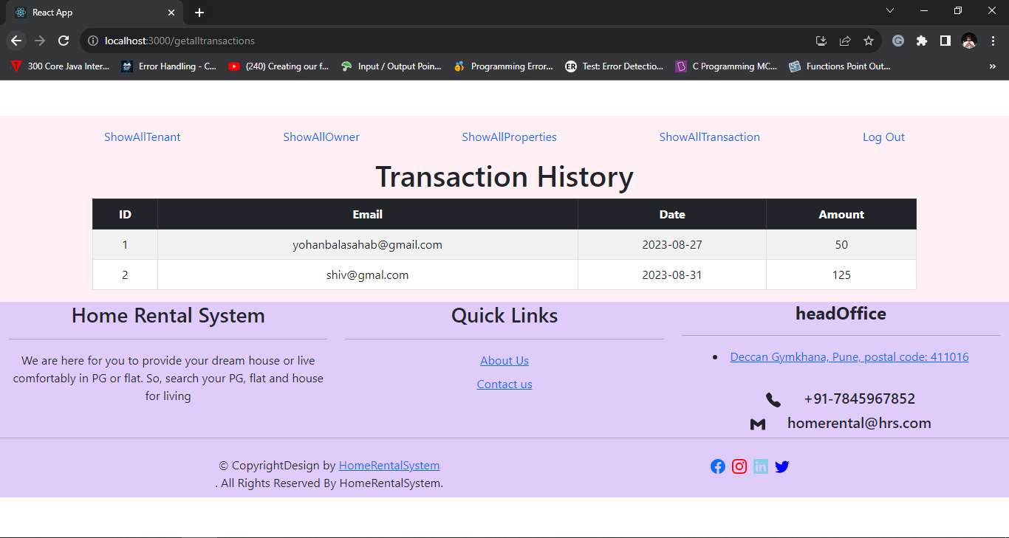

**8.4 Owner**

**8.4.1 Add Owner Page**

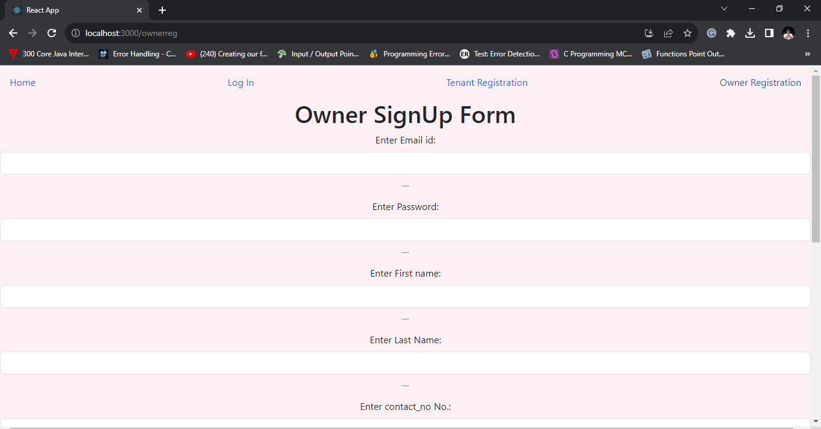

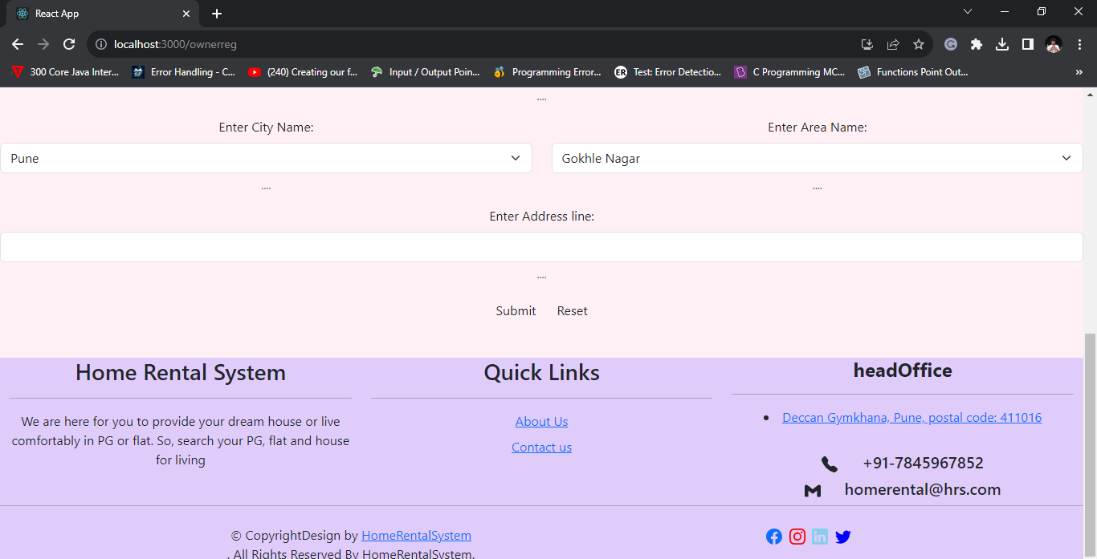

**8.4.2 Owner Registration Payment Page**

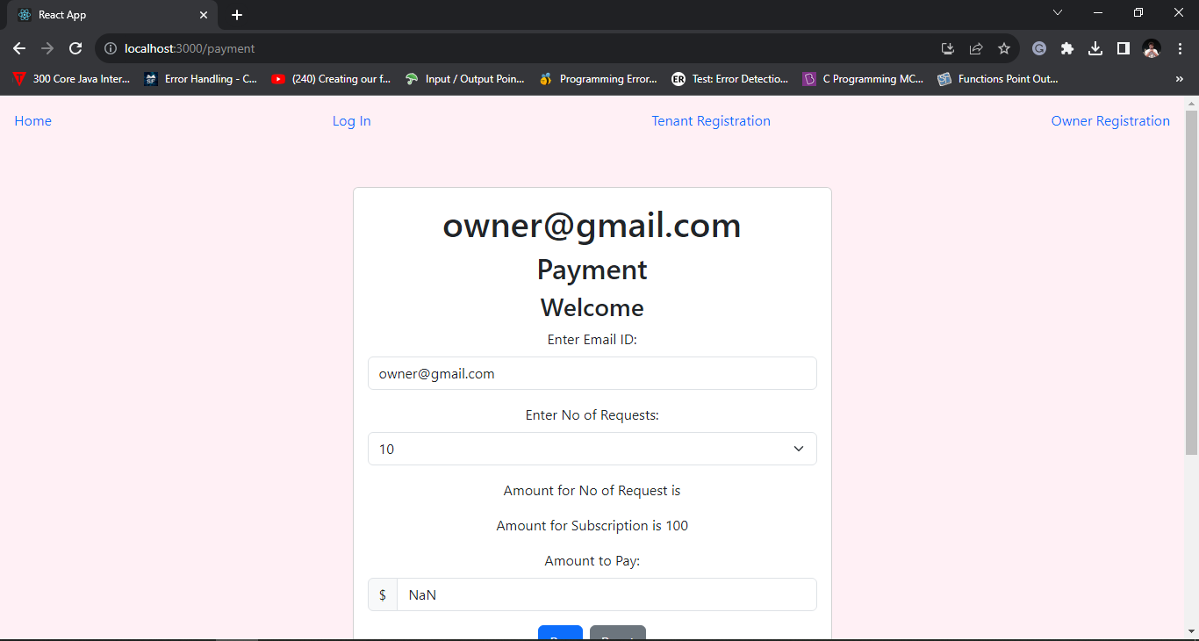

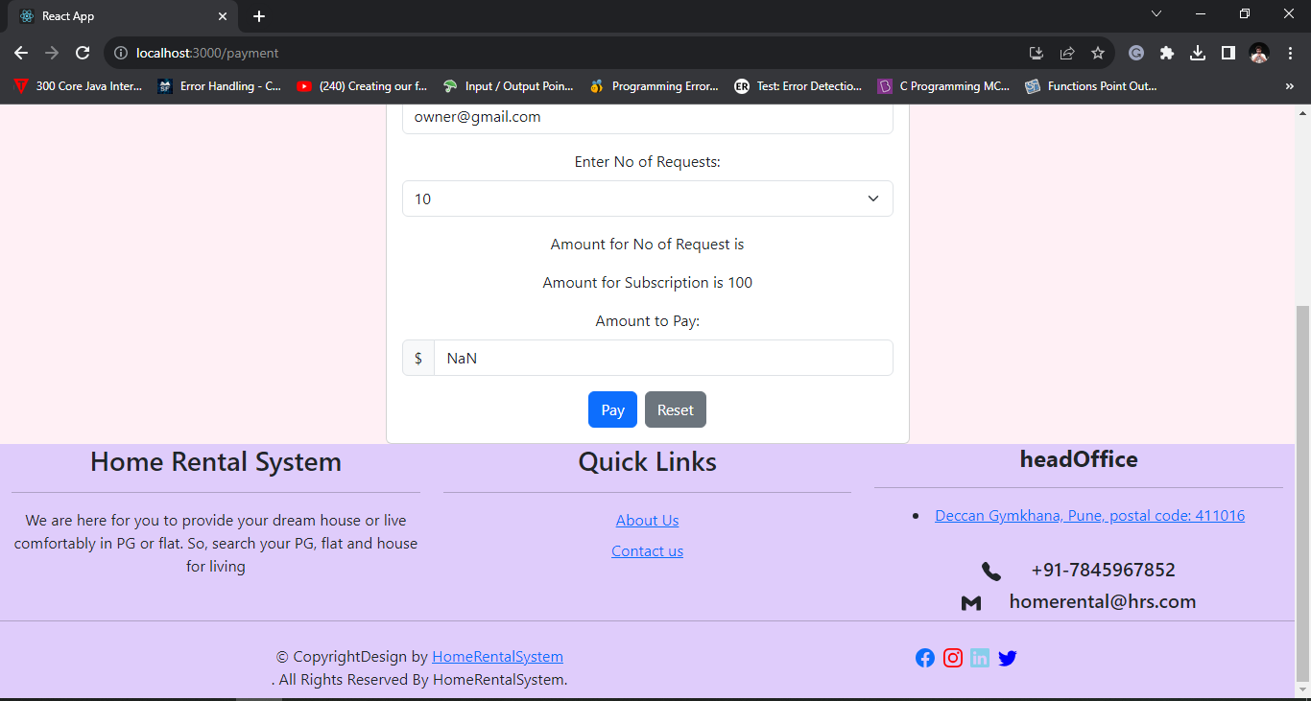

**8.4.3 Owner Home Page**

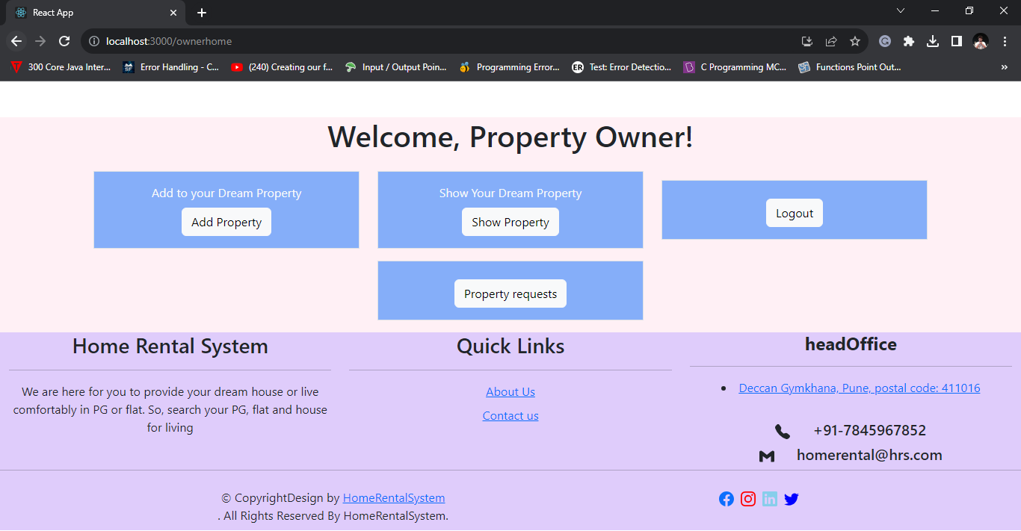

**8.4.4 Owner - Property Information Page**

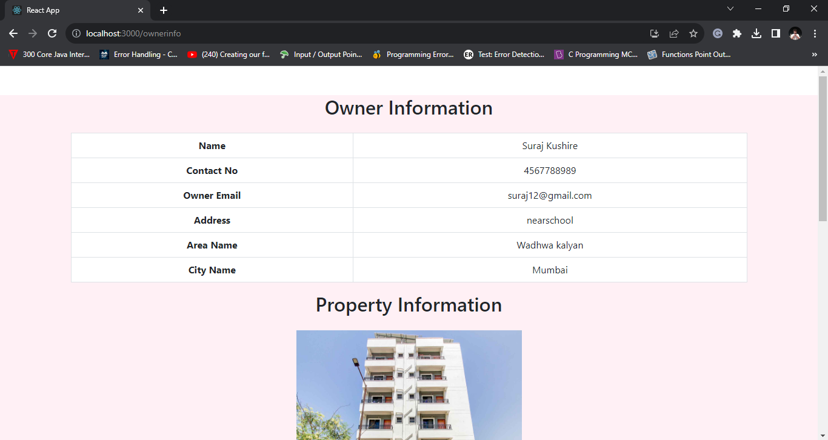

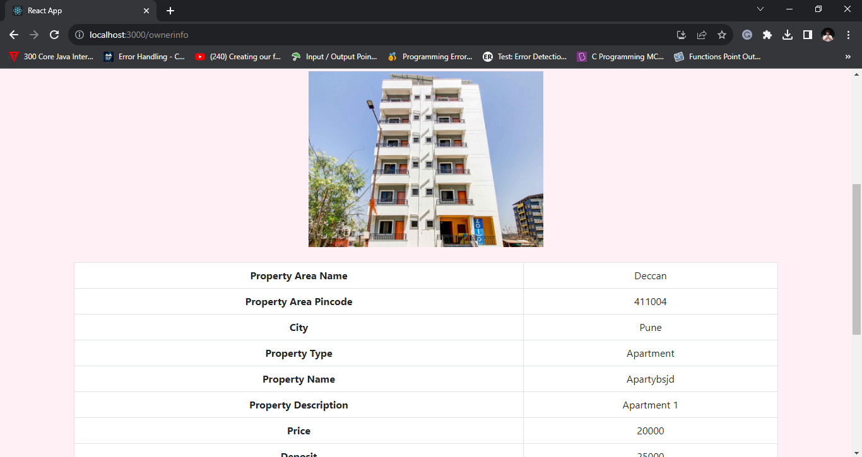

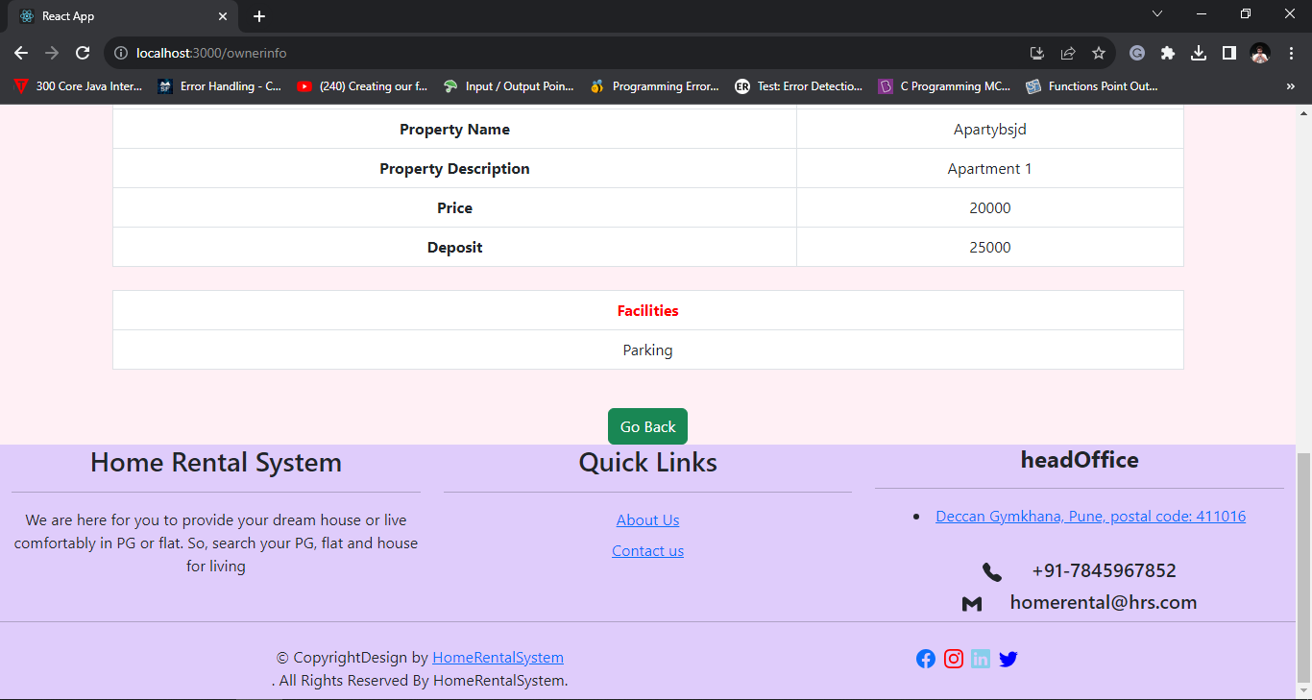

**8.4.5 Owner Add Property**

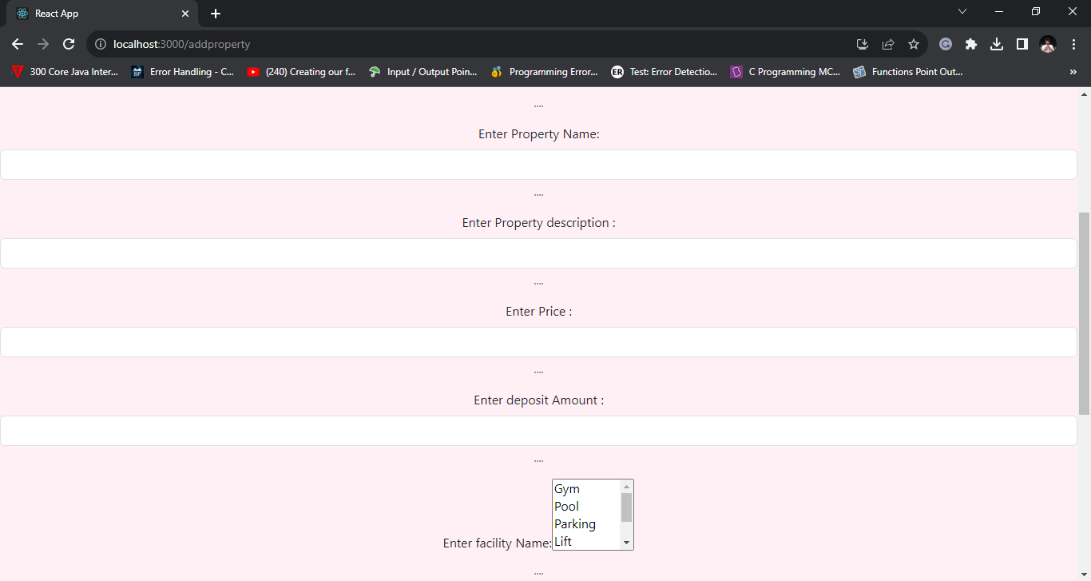

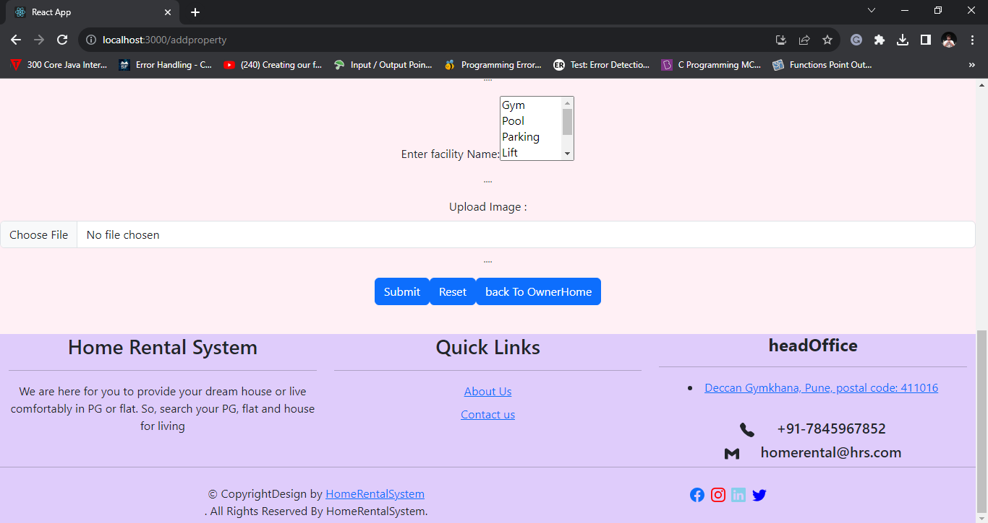

**8.4.6 Owner - Tenant Requested for owner information**

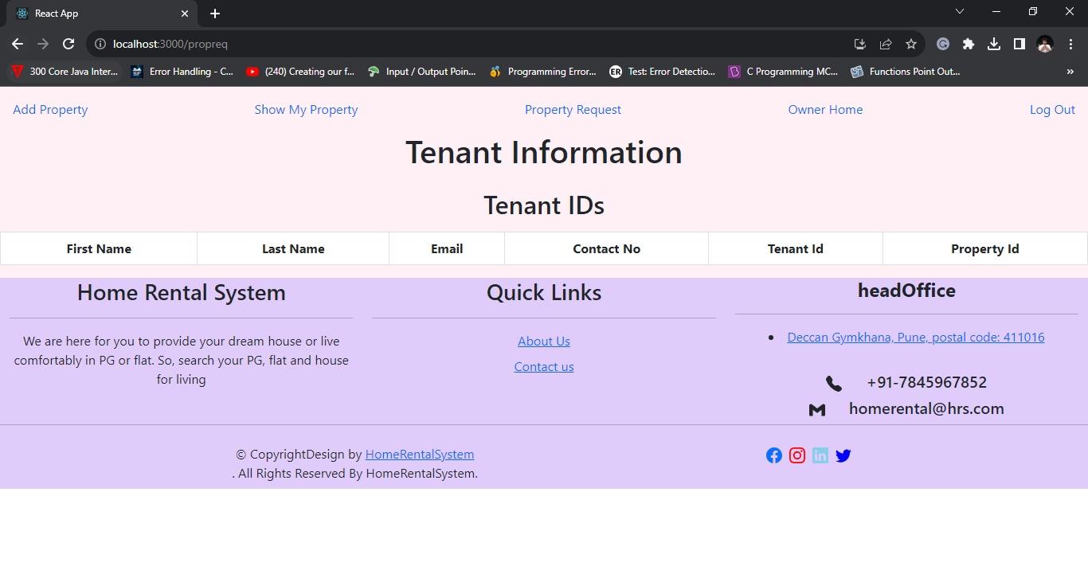

**8.5 Tenant**

**8.5.1 Tenant Registration Page**

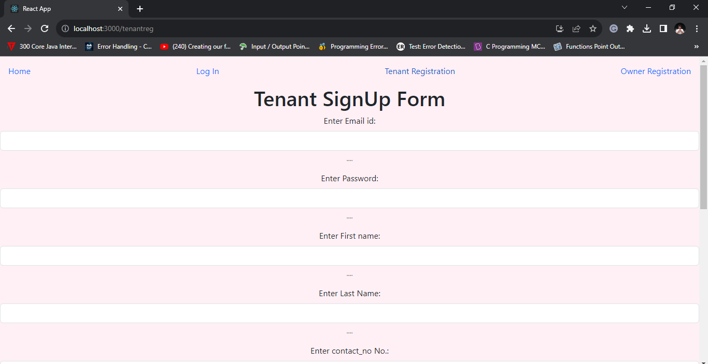

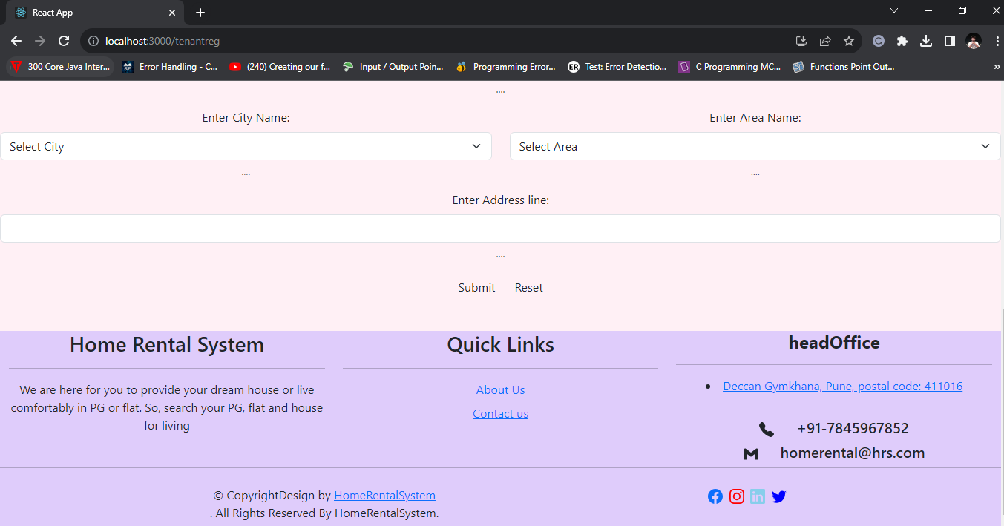

**8.5.2 Tenant Payment Page**

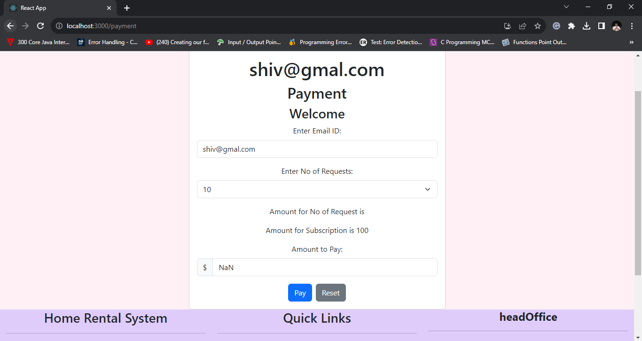

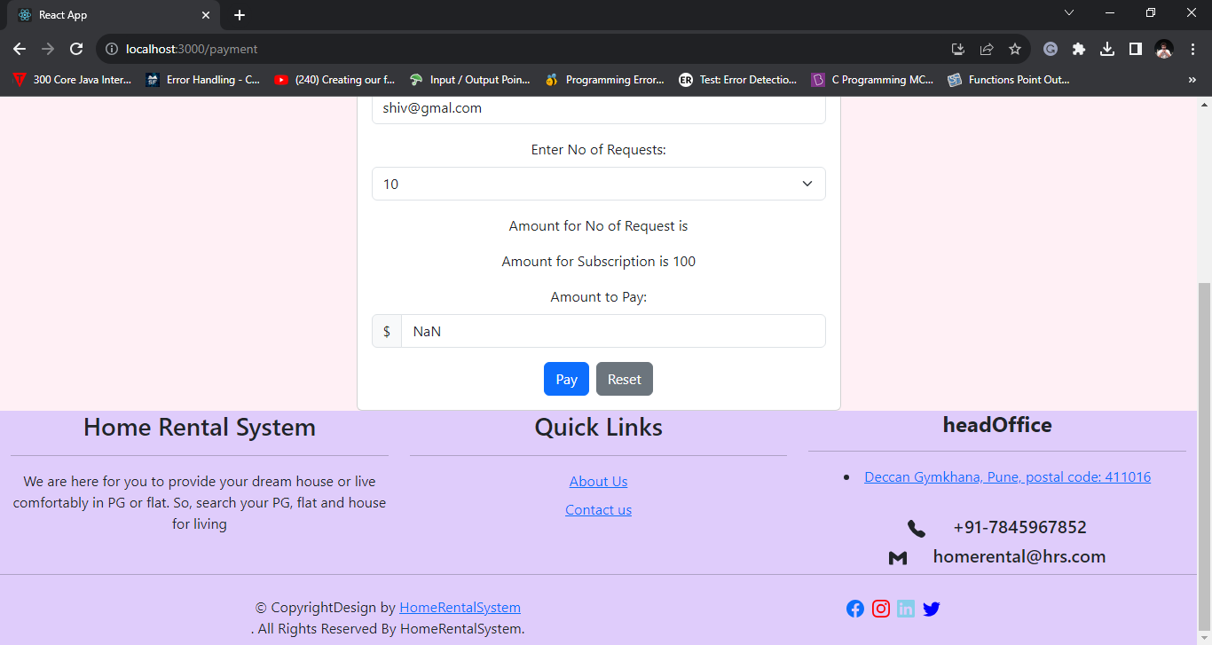

**8.5.3 Tenant Home Page**

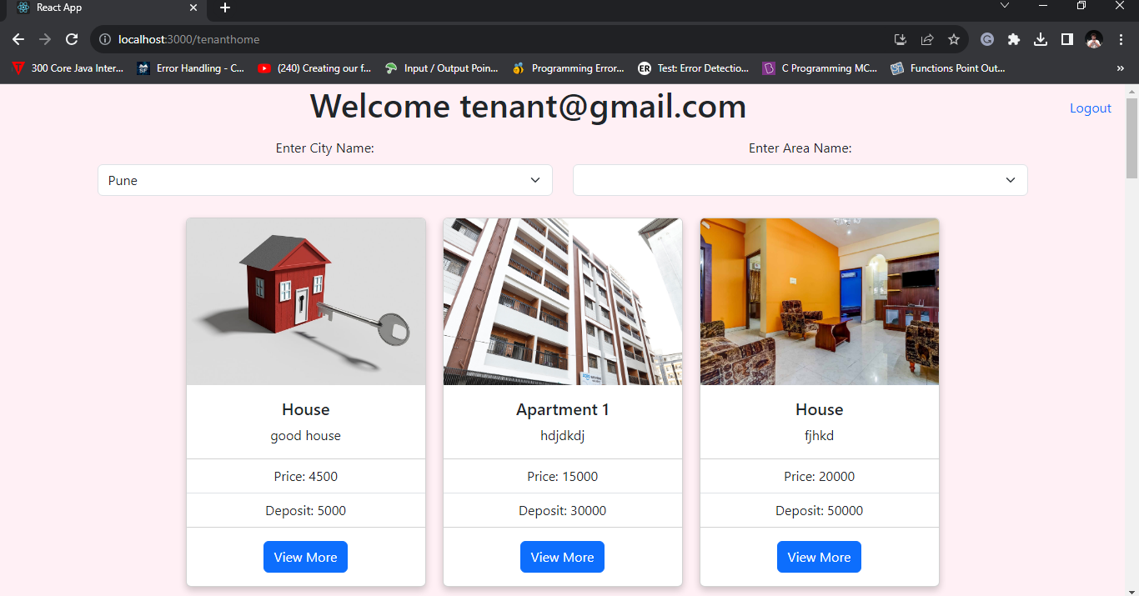

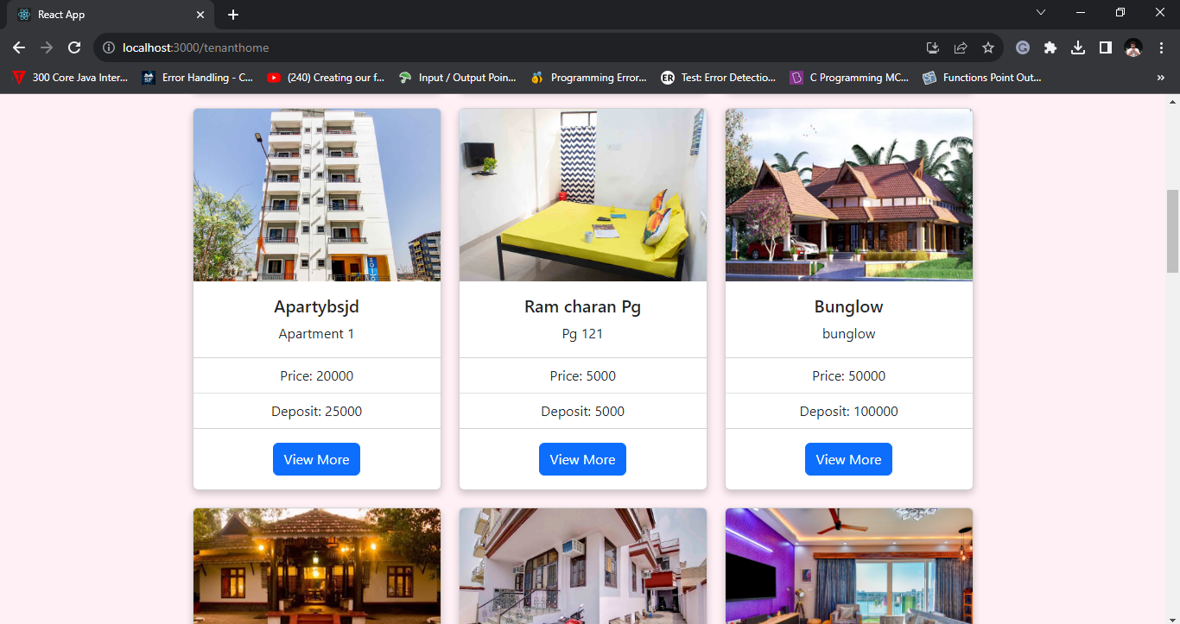

**8.5.4 Tenant Owner - Property Details**

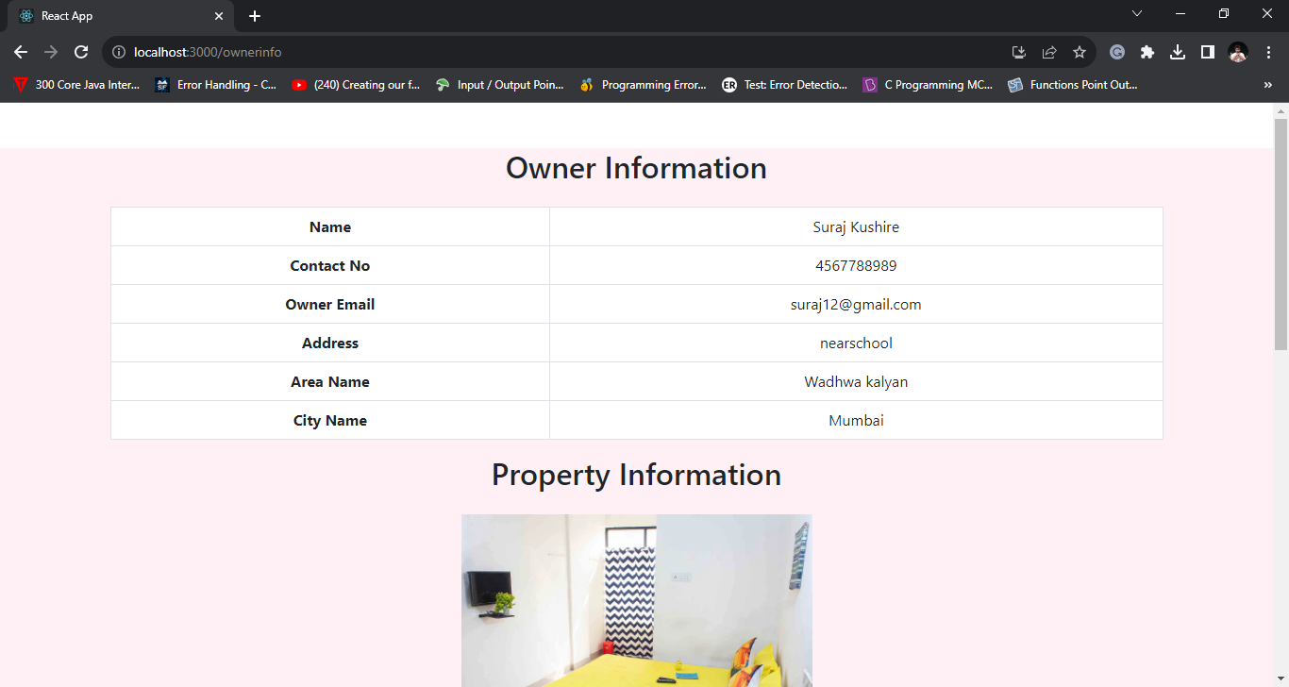

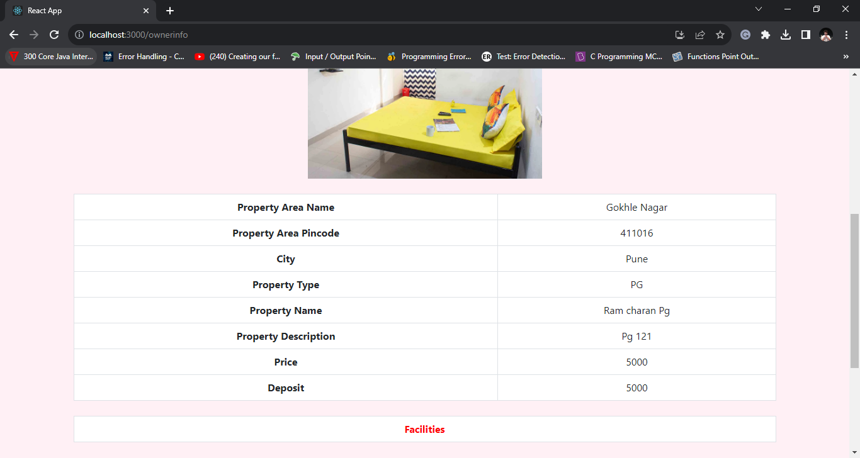

1. **CONCLUSION AND FUTURE SCOPE**

The Home Rental project presents a comprehensive solution to address the challenges faced by both tenants and property owners in the real World. By providing a user-friendly online platform, it streamlines the rental process, enhances transparency, and fosters direct communication between tenants and property owners. The project offers a range of benefits, including time and cost savings, market insights, and global accessibility. As it expands and evolves, it has the potential to transform the way people find and rent properties, offering convenience and efficiency to users in the dynamic world of real estate.

Our system provides a straightforward and user-friendly platform that allows tenants to effortlessly search for flats and homes using images, based on their specified city and area preferences.

**Future extensions for the Home Rental project could include:**

Mobile App Development: Creating mobile apps for Android and iOS to enhance user accessibility and engagement.

Payment Integration: Integrating payment gateways for seamless rental transactions and secure online payments.

Advanced Search Filters: Implementing advanced search options like filtering by amenities, location, and price range.

Rating and Reviews: Adding a rating and review system for properties and tenants to build trust within the community.